# Acknowledgement

The satisfaction that accompanies that the successful completion of any task would be incomplete without the mention of people whose ceaseless cooperation made it possible, whose constant guidance and encouragement crown all efforts with success. We are grateful to our project guide **Ms. Vaidehi Patel** for the guidance, inspiration and constructive suggestions that helped us in the preparation of this project. Without her encouragement and guidance this project would not have materialized. The guidance and support received from all the members who contributed and who are contributing to this project, was vital for the success of the project. I am grateful for their constant support and help.

**Abstract**

The project Arduino based Hand Gesture Control of Computer is implemented using Python.

In this project, we can find the basics of how to use the Arduino with Python, installing Python on our computer, setting up the Serial Library (important for communicating with Arduino) and the project codes.

This project presents a novel technique for recognizing the gestures as well as symbols made by hand via human computer interaction. The main objective is to explore the power of recognize the gestures made by a human hand.

The image of the gesture of hand is captured and processes through stages like image processing, gesture extraction and identification.

The first stage extracts the image of hand and separates it from the background.

In the next step, the gesture is processed and other noises are filtered and in the third step the gesture is matched with the set of data which is predefined.

After the hand gestures are processed and recognized using various techniques and functions, the command that the gesture represents is send to the Arduino which moves accordingly. In addition to the left, right, move and stop commands it can have more abilities to work according to user requirements by modifying it.

**TABLE OF CONTENTS:**

Acknowledgement 01

Abstract 02

Table of Contents 03

List of Figures 04

1. Introduction 05

1.1 Introduction 05

* 1. Aims and Objective of the work 05
  2. Brief Literature Review 05
  3. Problem definition 06

1.5 Plan of their work 06

1. Technology and Literature Review 09
2. System Requirements Study 10

Hardware and Software Requirements

1. System Diagrams 11
2. Result, Discussion and Conclusion 15
3. References 16

# List of Figures

|  |  |  |
| --- | --- | --- |
| **Figure 1** | **: Arduino UNO board** | **5** |
| **Figure 2** | **: Ultrasonic Sensor** | **6** |
| **Figure 3** | **: Ultrasonic sensor working diagram** | **6** |

**Figure 3(a): Diagrammatic view of sensor 6**

**Figure 4 : Circuit Diagram of the System 7**

**Figure 5 : Block diagram of the System 7**

**Figure 6 : Use case diagram of the System 10**

**Figure 7 : Flowchart of the System 11**

**Figure 8 : Activity diagram of the System 12**

**Figure 9 : Class diagram of the System 14**

# Introduction

## 1.1 Introduction

You might have seen Hand Gesture Controlled Robots, where the motion of a robot is controlled by the gestures of the hand. Another interesting project based on a similar principle is an Arduino based Hand Gesture Control of your computer or laptop.

Human Machine Interface or HMI is a system comprising of hardware and software that helps in communication and exchange of information between the user (human operator) and the machine.

We normally use LED Indicators, Switches, Touch Screens and LCD Displays as a part of HMI devices. Another way to communicate with machines like Robots or Computers is with the help of Hand Gestures.

Instead of using a keyboard, mouse or joystick, we can use our hand gestures to control certain functions of a computer like play/pause a video, move left/right in a photo slide show, scroll up/down in a web page and many more.

In this project, we have implemented a simple Arduino based hand gesture control where you can control few functions of your web browser like switching between tabs, scrolling up and down in web pages, shift between tasks (applications), play or pause a video and increase or decrease the volume (in VLC Player) with the help of hand gestures.

## 1.2 Aims and Objective of the work

Basic aim of the project is to control any computer system without touching it and in reliable way i.e. anyone can easily use it using some of the preinstalled hand gesture commands.

It is possible to customize this as per user’s requirement and needs.

## 1.3 Brief Literature Review

This paper introduces a technique based on determining distance by the sensor and accordingly a particular function is performed. Some recognition method of the gestures are proposed and then actions are recognized Using sensor .We set up few mainstream methods based on the action recognition by the sensors. The sensor Device is attached on computer at head of the screen, for quick operation. In this field much research work has been done but that work is related to hand recognition, real time finger recognition and recognition of alphabet characters. Real time human computer interaction using hand gesture, are also used for many functionalities such as video control, music player, gaming , controlling the functions of PDF reader etc. All these interactions have real time gesture recognition techniques. A gesture controller resolution always requires a physical device which follows and recognizes the body language or movements, so that the computer can clarify them. By

using ultrasonic sensor, the distance of hand can be found which acts as an Input. According to the distance of hand, particular function is performed.

## 1.4 Problem definition

Some of the major problems faced by traditional human computer interaction methods are as follows:

1) Disabled people and amputees find it difficult to interact using traditional human-computer interaction method.

2) They limit the users to a single point of input.

3) It increases the complexity of human interaction with computer.

4) Sensor provides only limited range for gesture recognition.

5) Some devices like mouse need an unobstructed and flat surface to effectively monitor and manage user movements. If these conditions are not satisfied they might create problems in human-computer interaction. These problems can be overcome by controlling the computer by our hand gestures.

## Plan of their work

## Methodology(Hardware)

* **ARDUINO UNO**

The Arduino Uno board is based on the ATmega328. Arduino UNO is an Open-Source Platform and easy to understand for beginners. A vital role in Arduino is played by its standard connecters which lets the CPU board connect to various add-on modules known as shields. Motor controls, GPS, Ethernet, LCD, or breadboard are provided by shield. Arduino IDE (integrated development environment) is used to program Arduino boards in C and C++ programming languages over a serial connection.

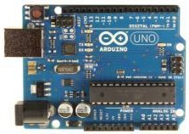

**Figure 1: Arduino UNO board**

* **Ultrasonic Sensor**

The ultrasonic sensor is used to determine distance to an object. It emits an ultrasound and this sound travels in the air. When it gets to an object it is reflected back to the ultrasonic sensor

.The ultrasonic sensor has four pins, these are: VCC, used to powers the sensor, Trigger, to send

the US waves, and Echo, the output pin .The US wave is returned back to sensor through eco pin and GND is connected to the ground pin of Arduino board.

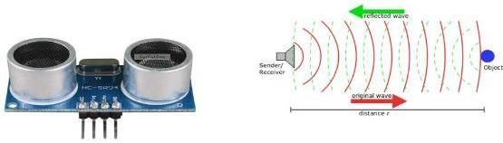

**Figure 2: Ultrasonic Sensor**

**WORKING**

Gesture controlling is based on specifying hand position from the ultrasonic sensor. For processing the raw data, a micro-controller is essential; for that we use Arduino UNO board. Via USB connection the microcontroller transfers the processed and calculated distance value which is provided by the sensor. The data which is send by the sensor is processed in the software in PC where all the calculations are performed and the data is matched with the predefined conditions (gesture resolution). In this model two ultrasonic sensors are used to detect hand position and are connected to the Arduino board .As we know ultrasonic sensor continuously emits sound and it gets reflected back from user’s hand. The distance between the sounds is send and detection of reflecting back sound wave is calculated by the micro-controller.

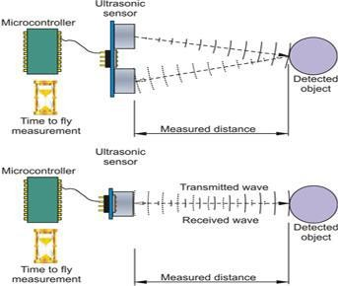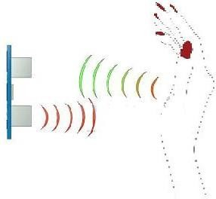

**Figure 3: Ultrasonic sensor working diagram Figure 3(a): Diagrammatic view**

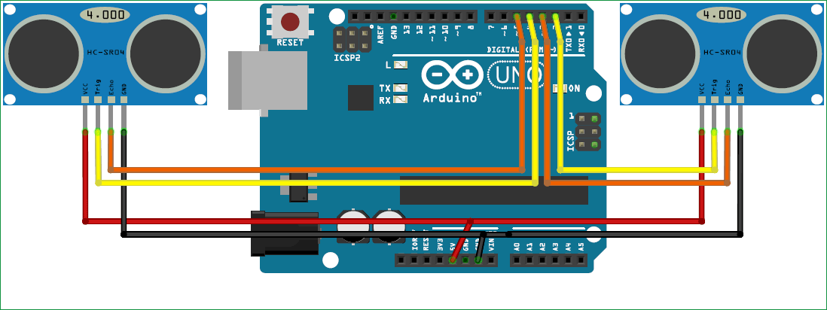

**Figure 4: Circuit Diagram of System**

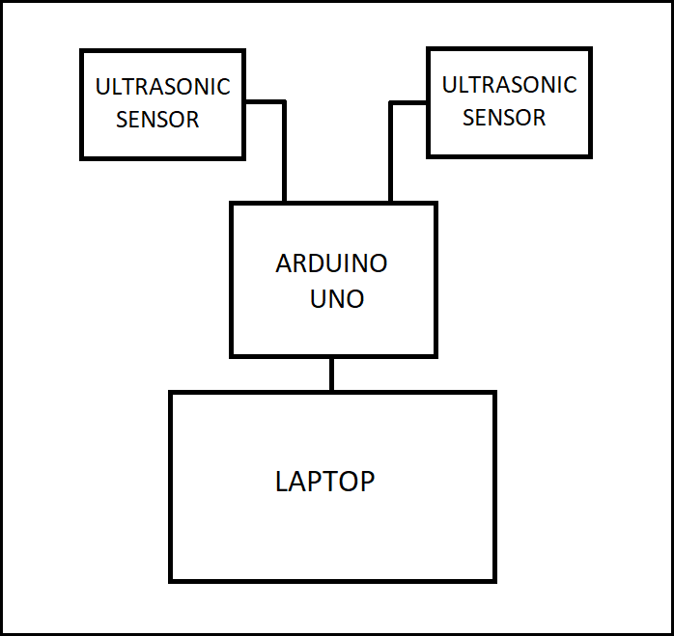

**Figure 5: Block Diagram of System**

# Technology and Literature Review

In this project, we interface Arduino with Python and implement a simple project on controlling Arduino with Python Programming Language.

Arduino is one of the most powerful open source electronics prototyping platform built around AVR Microcontrollers. Python, on the other hand, is one of the most widely used open source high level programming languages.

Combining Arduino and Python will open doors to a wide range of ideas, projects and combinations. One such application is the Internet – of – things or IoT, which requires features like Communication Interfaces like Serial, graphical user interfaces, web interfaces, data storage and many others.

Python has a huge collection of libraries that are open source and easy to use, which makes Python Programming Language the most suitable language for IoT Applications.

## Python Programming

We can write python code in pyCharm IDE(integrated development environment) or simple Python IDE, both are open source IDE and easily available on the Internet for download.Writing Python Program for Arduino based Hand Gesture Control is very simple. You just need to read the Serial data from Arduino and invoke certain keyboard key presses. In order to achieve this, you have to install a special Python Module called PyAutoGUI With the help of PyAutoGUI, we can write a Python Program to mimic the actions of mouse like left click, right click, scroll, etc. and keyboard like key press, enter text, multiple key press, etc. without physically doing them.

After install PyAutoGUI library,install another library named as PySerial In order to access the Serial Port of the Computer through Python,.pySerial is a Python Serial Port Extension that provides access to the Serial Port for Python running on different Operating Systems like Windows, Linux, Mac OS (OSX), etc.

## Arduino Programming

The Arduino IDE is a [cross-platform](https://en.wikipedia.org/wiki/Cross-platform) application (for [Windows](https://en.wikipedia.org/wiki/Windows), [macOS](https://en.wikipedia.org/wiki/MacOS), [Linux](https://en.wikipedia.org/wiki/Linux)) that is written in the programming language [Java.](https://en.wikipedia.org/wiki/Java_(programming_language)) It originated from the IDE for the languages [*Processing*](https://en.wikipedia.org/wiki/Processing_(programming_language)) and [*Wiring*](https://en.wikipedia.org/wiki/Wiring_(development_platform)). It includes a code editor with features such as text cutting and pasting, searching and replacing text, automatic indenting, [brace matching](https://en.wikipedia.org/wiki/Brace_matching) and [syntax highlighting](https://en.wikipedia.org/wiki/Syntax_highlighting), and provides simple *one- click* mechanisms to compile and upload programs to an Arduino board. It also contains a message area, a text console, a toolbar with buttons for common functions and a hierarchy of operation menus. The Arduino IDE supports the languages [C](https://en.wikipedia.org/wiki/C_(programming_language)) and [C++](https://en.wikipedia.org/wiki/C%2B%2B) using special rules of code structuring.

# System Requirements Study

# Hardware/Software Requirement

# Hardware Requirement

1. HC-SR04 Ultrasonic Sensors
2. Arduino Uno board
3. Connection wires
4. Laptop (Windows 7/8/10 OS)

## Software Requirement

1. Arduino IDE
2. Python 3.8
3. VLC Media Player, Browser

# System Diagrams

1. **Use Case Diagram:**

A use case diagram at its simplest is a representation of a user's interaction with the system that shows the relationship between the user and the different [use cases](https://en.wikipedia.org/wiki/Use_case) in which the user is involved. A use case diagram can identify the different types of users of a system and the different use cases and will often be accompanied by other types of diagrams as well. The use cases are represented by either circles or ellipses.

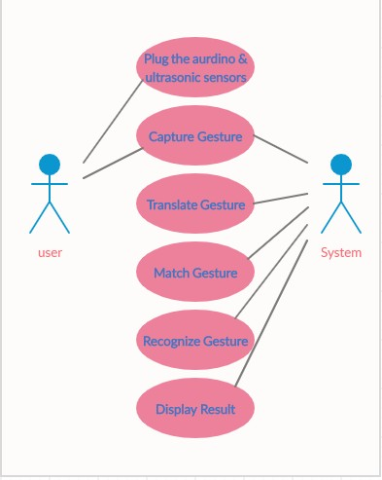

**Figure 6: Use case Diagram**

1. **Flowchart**

A flowchart is a type of diagram that represents a workflow or process. A flowchart can also be defined as a diagrammatic representation of an algorithm, a step-by-step approach to solving a task. The flowchart shows the steps as boxes of various kinds, and their order by connecting the boxes with arrows.

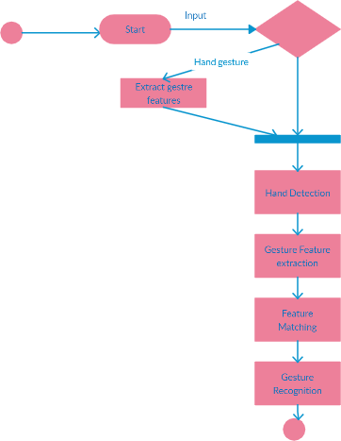

**Figure 7: Flowchart**

1. **Sequence Diagram**

Sequence Diagrams are interaction diagrams that detail how operations are carried out. They capture the interaction between objects in the context of a collaboration. Sequence Diagrams are time focus and they show the order of the interaction visually by using the vertical axis of the diagram to represent time what messages are sent and when.

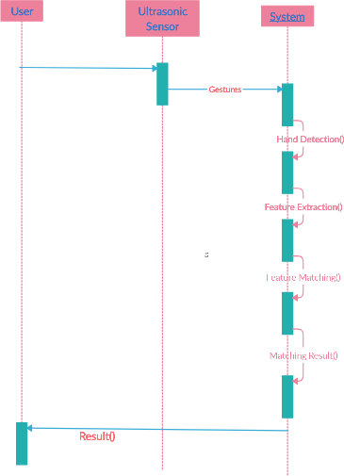

**Figure 8: Sequence Diagram**

**4) Class Diagram:**

A class diagram models the static structure of a system. It shows relationships between classes, objects, attributes, and operations. The class diagram is the main building block of [object-oriented](https://en.wikipedia.org/wiki/Object-oriented_programming) modeling. It is used for general [conceptual modeling](https://en.wikipedia.org/wiki/Conceptual_model) of the structure of the application, and for detailed modeling translating the models into [programming code](https://en.wikipedia.org/wiki/Programming_code). Class diagrams can also be used for [data modeling](https://en.wikipedia.org/wiki/Data_modeling).

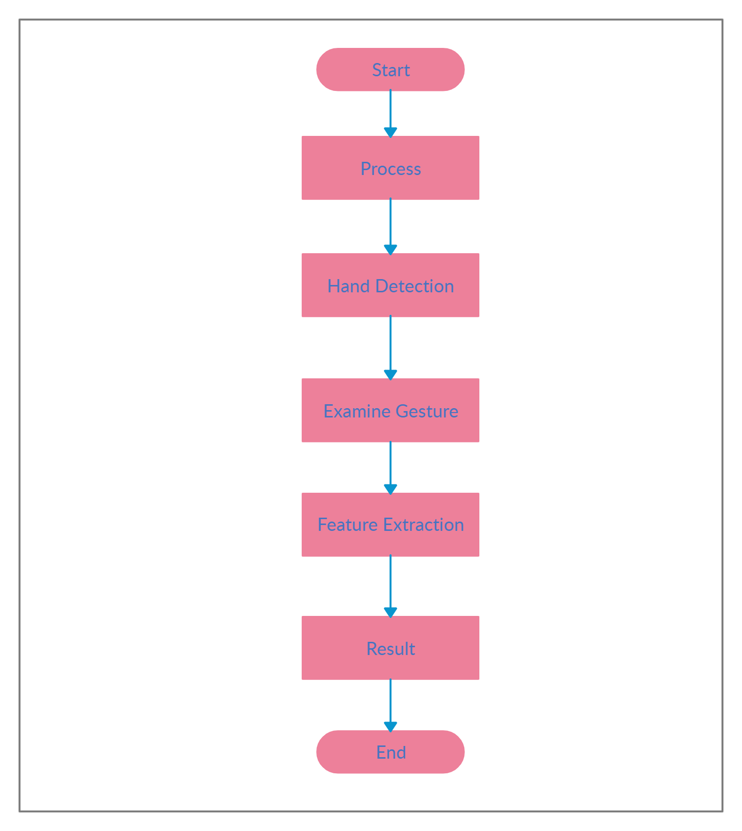

**Figure 9: Class Diagram**

# Result, Discussion and Conclusion

**Benefits of the Projected System**

* For this system there is no need of sound to be created so no interruption of background noise
* A number of functions of computer can be operated by using ultrasonic sensor.
* This technique may be very useful for those who does not know functionally of computer. This technique decreases the learning time required.
* Using this technique it is easy to interact with the computer and there is no language barrier.
* By using this system we can control our laptop from a small distance and it can help to control laptop in conference room presentation.

**Observation**

The sensor which is used in this system consumes very less power. The module is developed in low cost. In this system ultrasonic sensor is used to detect hand gesture or distance of hand and according to condition operation is perform on computer. The solution shown in article is implementable and very useful for the user.

## Future Scope

Hand gesture technique is not only limited to gaming, using basic function of computer it can be useful for medical applications. Hand gesture technique can work as input method between medical instruments and human body as proposed. It can be used for operating each and every functions of computer.

## Conclusion

This article presents one of the solution among various others, for operating a computer using hand gestures. It is one of the easiest way of interaction between human and computer .It is a cost effective model which is only based on Arduino UNO and ultrasonic sensor. The python IDE allows a seamless integration with Arduino UNO in order to achieve different processing and controlling methods for creating new gesture control solutions.

# References

# 





**LDRP Institute of Technology and Research**

**Bachelor of Engineering**

**Department of**

**Computer Engineering**

**Project Progress Report Card (Semester - 06)**

**Title of Project: - ARDUINO BASED HAND GESTURE CONTROL FOR COMPUTER**

**Enrolment No.: -** **1721BECE30211**

**1721BECE30220**

**1721BECE30228**

**1721BECE30247**

**Name of Student(s):**- **JEET PAREKH**

**JANVI PATEL**

**YASH PATEL**

**PRINCE TITIYA**

**Internal Guide Name: - Ms. Vaidehi Patel**

**Exam Date: / /2020**

**Comments of Internal Project Progress Review (Semester-6)**

|  |  |
| --- | --- |
| **Comments Given by Internal Examiners** | **Modification done based on Comments** |
| **Internal Examiners:**  **Name: Name:**  **Sign: Sign:** | **Internal Guide:**  **Name :**  **Sign:**  **Date:** |

**Exam Date: / /2020**

**Comments of Internal Project Progress Review (Semester-6)**

|  |  |
| --- | --- |
| **Comments Given by Internal Examiners** | **Modification done based on Comments** |
| **Internal Examiners:**  **Name: Name:**  **Sign: Sign:** | **Internal Guide:**  **Name:**  **Sign:**  **Date:** |